NVS Reference Sheet
This document is a quick reference of NVS Points of Contact for accredited representatives. For any issue not mentioned below, contact your Regional Quality Assurance Specialist. When contacting NVS, ensure you include the veteran’s name, VetraSpec ID if applicable, and a brief description of the issue.

Administrative Questions
Theresa Aldana Manager, Administration & Support Operations Administrative inquiries, accreditation questions, travel and lodging questions for training, VetraSpec access, DSO monthly reports.
Email: Taldana@vfw.org Phone: (202) 608-8347
Pre - Discharge Claims
Gregg Orto Deputy Director, NVS: Questions related to pre-discharge claims including inquiries about rating reviews for pre-discharge claims.
Email: Gorto@vfw.org Phone: (202) 608-8375
Policy Questions
Brad Hazell Assistant Director, Compensation & Pension Policy: Concerns or issues with VA Regional Offices (VARO). Potential misfiled claims or VA/VFW policy questions.
Email: Bhazell@vfw.org Phone: (202) 608-8366
Health Questions
James Moss Assistant Director, Veterans Health Policy: Health related questions about VHA. Issues with VHA or VA outsource facilities including issues with billing for VA appointments.
Email: Jmoss@vfw.org Phone: (202) 608-8371
Board of Veterans Appeals Questions
Jeff Wishneski Associate Director, Board of Veterans Appeals: Administrative questions about BVA appeals and hearings.
Email: Jwishenski@vfw.org Phone: (202) 632-4605
Training & Quality Assurance Questions
Chris Macinkowicz Assistant Director, Training & Quality Assurance: Questions about training curriculum, training conferences, and the VFW online learning portal.
Email: Cmacinkowicz@vfw.org Phone: (202) 608-8345
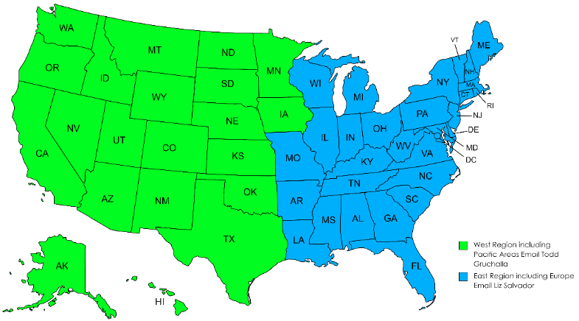

Todd Gruchalla Regional Quality
Assurance Specialist (West)
E-mail: Tgruchalla@vfw.org
Phone: (206) 900-1224

Liz Salvador Regional Quality
Assurance Specialist (East)
Email: Lsalvador@vfw.org
Phone: (202) 731-4137
Europe - East
Pacific Areas - West



