Tyler’s Veteran’s Benefits (TVB)

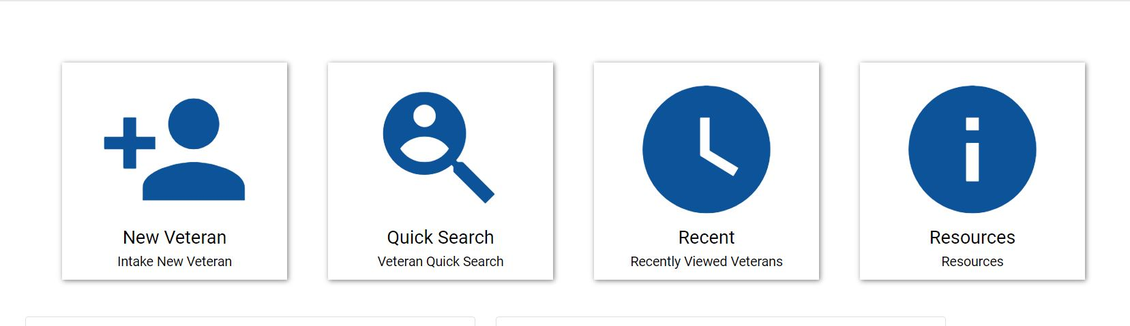
Creating the Veteran Folder

- From the TVB Home Screen click the + New Veteran Button
- Fill in the *Required Fields*:
    - Intake Date (Automatically populates to today’s date)
    - First Name
    - Last Name
    - SSN
    - Address (The County default setting is USA but with the TVB 4.1 release international addresses can now be captured.)
    - Veteran Status (Set Veteran Status to Active)
- Field Office – Click Assign to me (Requires you to set up your field office first in the My account the first time you log into TVB)
- Capture any other information you may have such:
    - Date of Birth
    - Email
    - Phone Number (The County default setting is USA but with the TVB 4.1 release international Phone Numbers can now be captured.)
- Click Save

**On the next page we will dive deeper into Navigating the Veteran Folder**

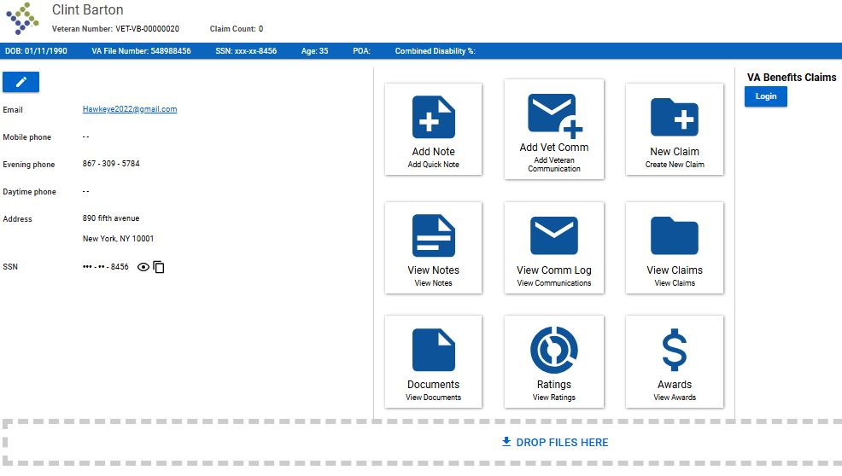
Navigating the Veteran Folder

Email Hyperlink
Edit Veteran

- Once a veteran profile is created you will be taken to the Veteran Home Screen as shown above.
- A unique Veteran Number is generated for each TVB Veteran folder and can be found underneath the veteran's name as outlined above. TVB numbers can be searched in the Quick Search Tile
- On The Veteran Page users can:
  - Upload documents by dragging files into the dotted box at the bottom
  - Create a Claim or view other Claims for the veteran.
  - Add or view communications
  - Log into VA Benefits Claims
  - Email the claimant using the TVB users default web email.
Special Notes:
- NVS does not recommend the use of “Notes” as these are isolated the TVB user account.
- The term “Claim” for TVB refers to anything being sent to VA and does not necessarily mean a traditional claim such as a 21-526EZ
- To access all the pages within the veteran folder click on the Blue Edit Veteran Button.

