**Tyler’s Veteran’s Benefits (TVB)**

**Creating the Claim Folder**

**The term “**Claim**” in TVB refers to **ANYTHING** being sent to VA such as medical documents, POA or even traditional claims such as a 21-526EZ**

1. From the Veteran Home Screen click the **New Claim** Button or hit the Edit Veteran button to find the **Claim Tab** and press **New Claim**
2. Fill in the \***Required Fields**\*:
   * 1. **Is Veteran** **the Claimant** (Automatically populates to yes but can be toggled to no which provides dependents entered into TVB as available choices)
     2. **Claim Type**: Most Common is Compensation but Burial Pension, Education and others are available.
     3. **Claim Status**: Active = Actual claims such as 526EZ, 686C all Incomplete claim: 21-22 or any other documents sent to
3. Click **Save**
4. This takes users to the Claim folder’s Home Page

**On the next page we will dive deeper into Navigating the Claim Folder**

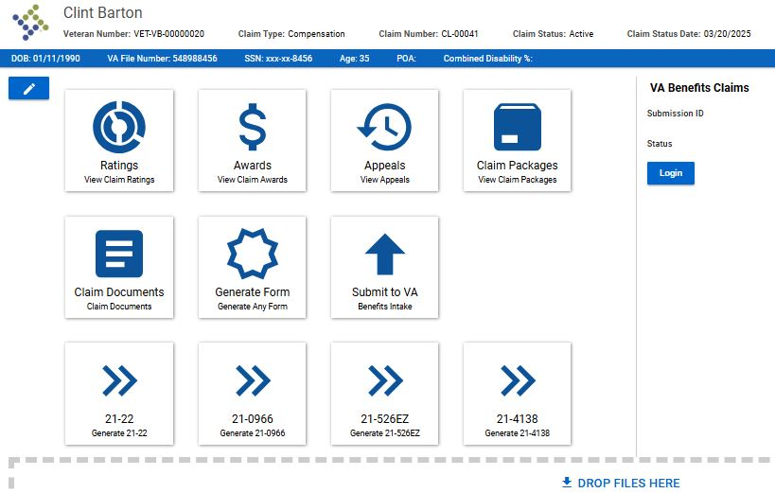**Navigating the Claim Folder**

**Edit Claim**

1. Once a claim is created you will be taken to the Claim Home Screen as shown above.
2. The Claim home Screen has Tiles that allow users to view or create items for the claim and take users to other pages within the folder
3. Click **Edit Claim** to view allClaim folder pages including:
   1. **Claim:** Shows claim information you previously entered
   2. **Document and Form:** Allows for the creation of VA forms
   3. **Claim package:** Used to send created claim documents and previously uploaded claim documents to VA
   4. Other pages are not frequently used but are self-explanatory

**Special Notes:**

* If you upload a document to the Claim Home Screen that document will only be found in that unique claim folder and **NOT** in the veteran folder