Tyler’s Veteran’s Benefits (TVB)

My Calendar Fact Sheet

- From the TVB Home Screen/Column click Quick Access. This automatically populates My Calendar; alternatively, you can hover over Quick Access and select My Calendar
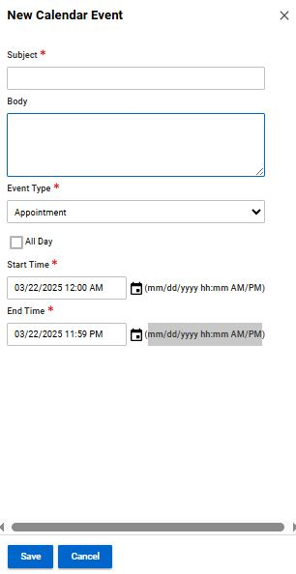
- The My Calendar page will populate displaying showing the current month and current day square being colored tan
- Calendar events can be created by clicking on the date of the event and entering in the required data:
- Subject
- Event Type (Auto populates to only option of Appointment)
- Start and End Time both requiring this specific entry method mm/dd/yyyy hh:mm AM/PM
- Click Save
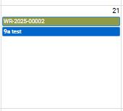
- On the My Calendar page any events that you create will populate as a Green line while any tasks that are assigned to you will populate as a Blue line.

