VA Laptop Request Instructions
The VA and the VFW have entered into an agreement to ensure accredited representatives are equipped with a VA-provided laptop. Please follow the following steps to request a laptop from VA.
**Please note that to submit the request users must be behind the VA firewall**
Requesting a Laptop
- Fill out the attached Request, Turn in and Receipt for Property or Services form attached with this notice
- Open VA’s IT page found Here behind VA’s Firewall
- Fill out the required fields using your information.
  - If you are submitting this request on behalf of someone else be sure to use their information)
- The box that states “Justification” use the following answer: “For enabling better outreach support of our Nation’s most vulnerable Veterans.”
- Once the page is complete, upload the signed MOA and Property Form into the attachment section by hitting Add Attachments located at the bottom of the page
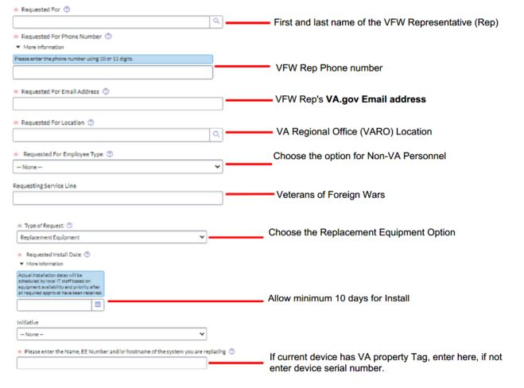

Important Items to Consider
- Failure to follow these directions will likely result in a denial of the request
- Departments are responsible for damaged or missing equipment; NVS will not refund or replace equipment damaged by VFW Reps
- Requests for specific laptop brands or types will not be considered; VA will provide laptops that meet the required specifications as outlined in the MOA which includes multiple different laptop brands

